Lab Exercise 19 - MinIO Console & Health Monitoring

This lab introduces basic monitoring of a MinIO server using only MinIO Client (mc) commands. You will verify console availability, check node status, inspect drive health, and confirm cluster readiness indicators without using external tools or logs.

Prerequisites
- MinIO server running (single-node or multi-node)
- MinIO Client (mc) installed
- MinIO alias already configured (example: myminio)
Verify alias:
mc alias list

Lab Environment Assumption
- Alias name: myminio
- Console enabled on MinIO server

Task 1: MinIO Console Overview (If Enabled)
Step 1.1: Verify MinIO server endpoints
mc admin info myminio

Expected Observation
- API endpoint displayed
- Console endpoint displayed (port 9001 or custom)
- Node information summary
Learning Point
- Presence of Console endpoint confirms that MinIO Console is enabled
- mc admin info is the primary command to validate console availability

Task 2: Check Node Status
Step 2.1: View node status and uptime
mc admin info myminio
Observe the following fields
- Node name / address
- Uptime
- Version
- Network status
Learning Point
- If node state is healthy, the cluster can accept requests
- In single-node setup, only one node will be listed

Task 3: Check Drive Health
Step 3.1: List disk and drive status
mc admin info myminio
What to check
- Drive count
- Online drives
- Offline drives (should be zero)
- Storage usage
Learning Point
- All drives must be online for a healthy MinIO node
- Drive issues directly affect read/write operations

Task 4: Cluster Readiness Indicators
Step 4.1: Verify overall cluster health
Curl -I http://127.0.0.1:9000/minio/health/live

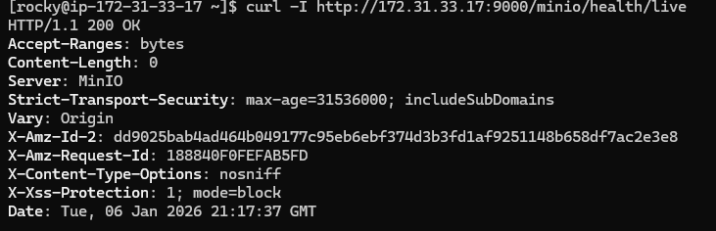

Curl -I http://127.0.0.1:9000/minio/health/ready
Expected:
